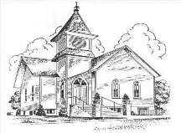
FIRST CHURCH CONNECTION

First Congregational UCC of Onekama,
4920 Spring St. PO Box 307 Onekama, MI. 49675

Church Phone 231-889-4081 e-mail appledumplingchurch@yahoo.com
Rev. Alison Andrea Young at 802-829-3211 or ajacobs.4818@gmail.com
January 2026

Pastoral Ponderings
Many holiday gifts came my way during the Christmas season. I want to thank you all for thinking of me and I am grateful for the generous monetary gift that you gave me, as well as all the other goodies (BTW who gave me the beautiful musical snow globe? No card was attached?) I feel so blessed by your love and generosity.
My trip to Cleveland was also a great blessing as I was able to get re-acquainted with my grandsons, Henry and Joey, and my granddaughter, Maya. They have all been growing and changing so much that I can hardly keep up! They are such great human beings.
Son Christopher (the elder) and his wife, Carolyn, are on a curling team and we spent one afternoon at the Skating Club as they practiced for a tournament. I read five novels and nursed my injured hand sitting by the fire with good coffee and even better tea (from Japan)! I also slept in every morning—what luxury!
Getting home was a hassle, but God brought me back safe and sound (at least as sound as I was before!) and I am truly grateful for God’s care of me during this trip and for all your prayers. They were truly felt. I relaxed for 8 days, that is a miracle in itself!
I will not be making any predictions about 2026. I have learned finally to truly take “one day at a time” and make the best that I can of it, doing the precious work that God has called me to do. May you all do the same!

With Love—Pastor Alison

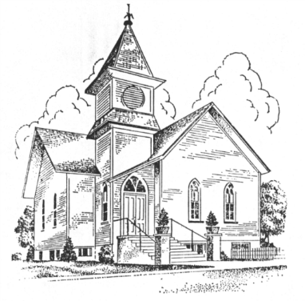
First Congregational United Church of Christ
P.O. Box 307
Onekama, MI 49675
Rev. Alison Andrea Young, Pastor
Church Phone: 231-889-4018
Pastor Phone: 802-829-3211
Email: appledumplingchurch@yahoo.com
FB: First Congregational Church of Onekama
Website: https://onekamaucc.org/

Onekama, MI—Exciting things are upcoming at the First Congregational UCC of Onekama in the new year! The church has successfully written and received grants to fund a series of Forums on “Aging Well in Onekama.” The grants were received from the National Office in Cleveland, the Michigan Conference, and the United Northern Association of the United Church of Christ. This effort is in coordination with the Portage Lake Association’s “Near & Farr Friends” program which began to explore this area in talks they sponsored in 2024; and the grant writing was successful due to a letter of support from the PLA. Topics that will be covered are, but not limited to: wills, living wills, budgeting, investments, avoiding scams, reverse mortgages, planned giving, risk of addiction, medical decision making, Hospice care, Home Health options, Caregivers’ issues, exercise programs, and spiritual wellness,
The church will present once-a-month forums on various topics concerning the needs of seniors in Onekama. The forums will be held at the church on the fourth Friday of every month from January through May, with a break for the summer months, and continuing in September and October. The hoped for end result will be a brainstorming session, using the information received in the forums, to decide on a major project based in Onekama to address these issues, for which further granting opportunities can then be explored. The forums will be held from 11am-1pm in the newly renovated church hall and will include a catered lunch by “Carefree Catering” (see Manistee News Advocate front page article on !2/13/25). The first forum is set for January 24th on the topic of exercise programs for seniors.
Come and enjoy a free lunch (yes—those really do exist!) and a wonderful time with the community working together for the betterment of everyone. FMI: Rev. Alison Andrea Young, 802-829-3211.

Community Outreach

January local food pantry
Collection items is hot cereal. Just drop them off at the back of the sanctuary and we will see they get to the St. Joseph Church.

Portager School Pantry We received a very nice thank you note for our first two donations to the Portager Pantry for Onekama Schools’ students. They were very appreciative. For our next round, the school would like to replenish their supply of dry shampoo in small purse sizes and Personal care items, mostly for girls: Hair ties, brushes, pimple cleansing pads; Crocs for children’s sizes (10-11-1-2); Microwavable Mac & Cheese They do not need clothing, water bottles, tampons or pads.
There is a collection bin at the back of the sanctuary.

Monthly 2026 Events & Dates Worship – Every Sunday at 10 a.m.
Financial Advisory Committee –will meet as announced.
Ministry Council – 3rd Thursday each month, this month will be by Zoom on January 15th, at 7:00pm
Game Night will meet in the fellowship hall with potluck on Friday the 16th at 6:00pm.
Choir Practice - Sunday afternoons 3:30 to 4:30pm.
Bible Study – is on Saturdays in Fellowship Hall (unless otherwise announced) 10-11:30am.
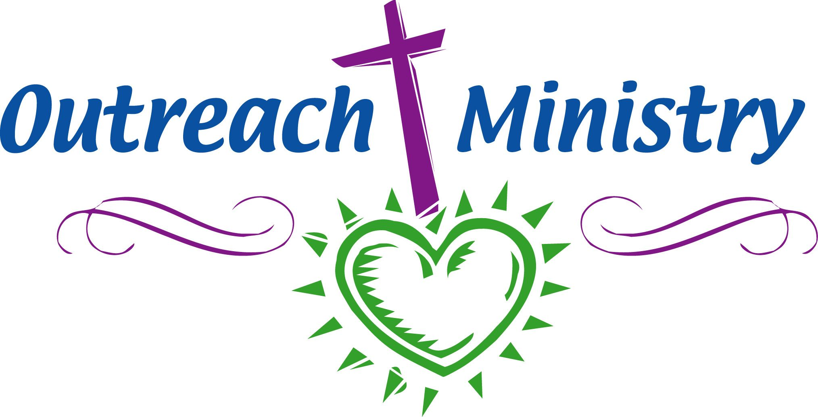

Sunday services at the Manistee County Medical Care Facility for 2026 are January 18th, April 19th, July 19th , and October 18th.
A small group has arranged to attend the first service on January 18th at 2 PM.


TOO MANY HOLIDAY SNACKS AND TREATS?
Are you looking to burn a few calories and improve your health while having fun with a jovial bunch of people?
If you answered “yes” to either of the above, then the twice-weekly “Stretch, Strength and Balance” class is for YOU!
EXERCISE CLASSES BEGIN TUESDAY, JANUARY 13TH
Tonya Evans’ exercise classes will return to our Fellowship Hall on Tuesdays and Thursdays 3:30
– 4:30 pm beginning January 13th. The class will be split into two sessions as follows: “Winter” session – Jan. 13 through March 12 9 weeks (18 classes) for $80 prepaid*
“Spring” session – March 24 through May 28 10 weeks (20 classes) for $85 prepaid**For the
discount, please pay on the first night of class for each session. Class Description:
A strong core, flexibility and balance are your most important assets regardless of your fitness level. This class incorporates core strength training, light weight training upper and lower body workouts, stretching and balance practice for an overall effective yet not so strenuous workout.
Bring your own weights, and yoga mat or towel for floor exercises. Chair exercises are an option to floor exercises.
About the instructor: Tonya Evans is a Physical Therapy Assistant at the Manistee County Medical Care Facility. She helps patients to follow an appropriate exercise program that will increase their strength, endurance, coordination, and range of motion. She has been in the business 27 years!
Come enjoy the fun, puns, upbeat music and great camaraderie... You know, misery loves company!

December Treasurer Report

Income from Contributions $9,602.00 Food Pantry $20.00
Memorial gift $25.00 White gifts cash collection $154.00
Poinsettia Flowers $120.00
Expenses of $10,813.14
We still owe on the Line of credit loan basement
project $3,154.11
Line of Credit loan parsonage shed $2,979.59

January
4th Carol Rackow
11th Steve Brooks
18th Shelly Lyman
25th Joy Lind

In the upcoming months, if there is a Sunday that you could help by volunteering, it would be greatly appreciated!
Just send me an email with the date.
Carol Rackow – rackey1992@gmail.com



January Birthdays Anniversaries
9th Dan Behring 25thMike & Shelly Lyman
16th Melissa Bray & Noel Niemann
20th Pam Lyman & Ed Kalis
21st Betsy Jasperser 27th Susie Halloran & Brooke McIsaac
28th Nancy Behring
29th Ann Hutchinson

Steps for viewing Facebook Live -Streamed Services…
Be sure to like our page on Facebook “First Congregational Church of Onekama”.
Find the three dots on a post. Click or touch the dots.
Scroll down and turn on notifications for this post.
You will be notified when the page goes live

Church Staff
Pastor – Rev. Alison Andrea Young
Choir Director – Dan Wilson
Moderator – Bill Sawhill
Vice Moderator - Marcia Rogers
Treasurer & Secretary – Joy Lind
Clerk – Lynn Jans
Pianist – Carolyn Brooks
Choir Accompanist - Kathy Wilson
Bell Choir Director – Carol Worch
Sexton – Carol Rackow

