“God---The Be-All and End-All” a sermon based on Psalm 118:1-2;14-24; 1 Corinthians 15:19-26; and John 20:1-18 delivered on Easter Sunday, April 20, 2025, at the First Congregational UCC of Onekama, Michigan by the Rev. Alison Andrea Young.

When we end the Lord’s Prayer like we do. We say “Thine is the kingdom, and the power, and the glory forever.” And then we say “Amen” –which in essence means in Hebrew “that’s the truth.” When Paul writes to the church in Corinth he is saying much the same thing. In Chapter 15 verses 24 to 28 Paul says that when the end comes, Christ “hands over the kingdom to God the Father,” and this is because “‘God has put all things in subjection under his feet.’ . . .When all things are subjected to him, then the Son himself will also be subjected to the one who put all things in subjection under him, so that God may be all in all.”

In the end, Paul writes, God will be “all in all.” God will BE “the kingdom, power and glory forever.” God will actually be “the be-all and end-all!” When Shakespeare coined the phrase “be-all and end-all” in 1605 and put it in the mouth of Macbeth, as he is contemplating assassinating King Duncan of Scotland and taking the throne for himself, I am sure he was not thinking of the church in Corinth or the Apostle Paul or God or even the Bible, but the phrase is so apt for our message today. This is so because, what Christ put to death on the cross, was sinful humanity—that of which Macbeth and Lady Macbeth were perfect symbols. The Resurrection of Our Lord Jesus Christ which we celebrate this morning is the precise liturgical statement that now, with the “Christ Event” death has been conquered, and God is the “Be-all and End-all” forever. God is the “Alpha and the Omega” (Revelation 1:8) the great “I AM” (Exodus 3:14) –God is “all in all.”

When Jesus admonishes Mary not to hold on to him, it is John’s way of reminding us that, while on the earth in any form, Jesus was fully human. In her book “Good Enough,” author Kate Bowler reminds us of the same thing. This “Be-all and end-all” God that we experience in Jesus, “knows what it’s like to live in the flesh. God went to great, even incarnational, lengths to be born as a tiny infant (John 1:14). If God too lived in a body, then God knows the ache of growing pains and the feeling of goosebumps on a brisk day, and the comfort of a warm embrace. . .felt the gurgle of hunger. Ours is a God who (as a man) sneezed and rubbed his eyes when he was sleepy. . .A God who knows what it means to live in a body.” (p. 157) Because of this, this is a God who knows our humanity “inside and out,” she says. It is only this “be-all and end-all” type God who would go to such lengths of taking on human flesh with all of its imperfections that could accomplish “conquering sin and death.” God becoming “all in all” is what we celebrate on this Easter Day and every Easter Day!

The Apostle Paul agrees. In his letter to the Corinthians, he says: “. . .in fact Christ has been raised from the dead, the first fruits of those who have died. 21For since death came through a human being, the resurrection of the dead has also come through a human being; 22for as all die in Adam, so all will be made alive in Christ.” The “all in all” God knows us inside out, upside down, and backwards. Our God is a hands-on God, not a distant relative. He counts our days (Psalm 139) and the hairs on our heads (Matthew 10:30) and knits us together in our mothers’ wombs (Psalm 139)!

The body of flesh and blood that we each inhabit is therefore something that God takes very seriously. It is not a secondary thing, but a primary one. We have all heard the phrase, “your body is the temple of the Lord.” As such, we are admonished to take care of it—to eat healthy things, not to abuse it with bad habits, to honor it in our physical relationships. While none of us know, on this side of death, what a resurrected body might be like, as Christian believers, we do know that there is one, because Jesus returned in at least thirteen post-resurrection appearances. Now sometimes, the people he appeared to did not recognize him right away, as we hear Mary did this morning. But eventually something triggers their hearts to know it is him. In Mary’s case, it was Jesus saying her name, But, then again, how many times in his pre-resurrection life did the Disciples and others not recognize Jesus for the person he really was???

In her Easter homily at Salisbury Cathedral in 2013, the Reverend Canon Sarah Coakley emphasizes that, as Christians, we must embrace the concept of resurrection in our “soul and mind and body.” We can’t leave the last part out. She says, “So here is the great truth at the heart of Christian faith: resurrection. Stake your life on it, struggle with it, and everything will change. Die, turn, see---and live in this mystical body which is the blessed community of all faithful.” And she goes on to say, “in due course ‘see’ the beloved Christ, as your senses and mind and desire are attuned to his presence there. He is, in a thousand faces of the poor; in those whom you love beyond measure and those whom you hate and spurn; in bread and wine and oil and the glories of the earth; and finally waiting for you as your life ends.. . .This isn’t, . . .a Christ who can be constrained within our grasp. But this is the Christ who has put suffering in its place, who has gone through it and beyond it and made us his own.”

There is a story told in the Talmud, the primary source of Jewish law, about a rabbi seeking the Messiah:

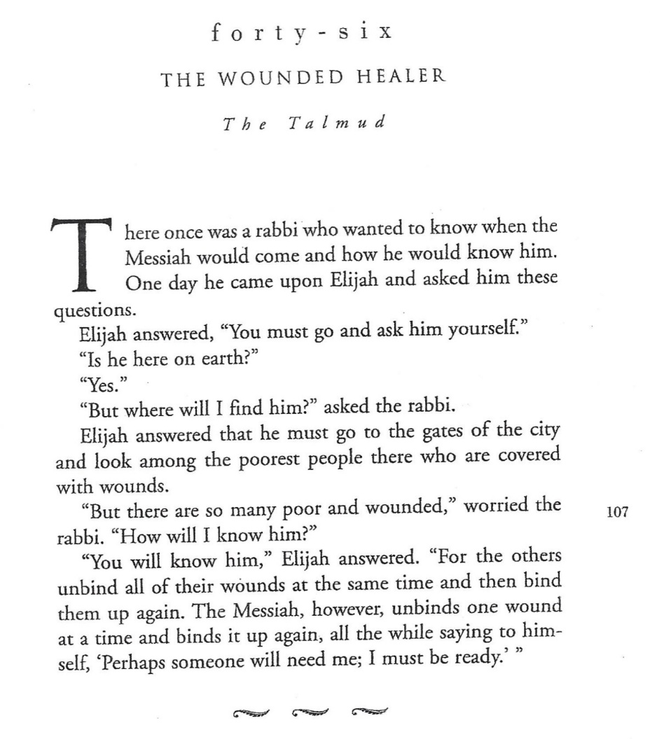  
 The resurrected Jesus is always ready! He is ready to bind our wounds, to rescue us from our enemies, and from ourselves, and to teach us how to live a life

aimed at our own final glorious resurrection. In his poem Manifesto: The Mad Farmer Liberation Front, poet Wendell Berry says it best:

*“So, friends, every day do something*

*that won’t compute. Love the Lord.*

*Love the world. Work for nothing.*

*Take all that you have and be poor.*

*Love someone who does not deserve it. , , ,*

*Be like the fox*

*who makes more tracks than necessary,*

*some in the wrong direction.*

*Practice resurrection.”*

The Reverend Canon Sarah Coakley in her Easter homily already cited earlier would agree, but she calls this instead, “practicing death.” She says, “But what it means is that only by handing ourselves over, as Christ was “handed over” by his betrayers in the Passion, into a seeming loss of selfhood, day after day, . . .will we find our true selves, the living Christlike selves that God longs us to be….” “To be a Christian” she continues, “is to ‘practice death’ this way, then, till we are no longer *afraid* of death; and when we are no longer afraid of death we are no longer afraid of Life, the ecstatic, abundant Life that Jesus holds out to us.”

Author, Nora Gallagher, quotes the Wendell Berry poem which I shared earlier as the introduction to her book entitled Practicing Resurrection, The book is a story of her journey struggling with a call to ministry and the death of her beloved brother Kit over a three-year period. In the final chapter she writes beautifully about what it has all meant.:

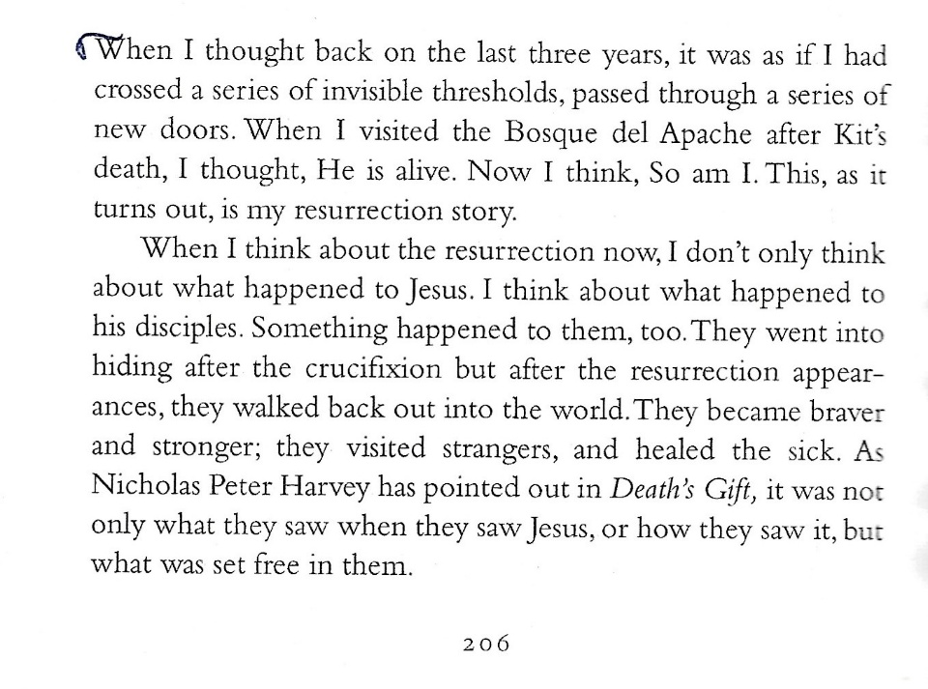

So, let’s follow the lead of these brave and articulate humans—The Psalmist, John the Evangelist, the Apostle Paul, the Rev. Canon Coakley, Nora Gallagher, and Wendell Berry, and go out into the world braver and stronger—and practice resurrection! Amen.

© Copyright 2025 by the Reverend Alison Andrea Young