“Dream Church” A Weekday Lenten Message based on Philippians 3:4b-14 delivered by the Rev. Alison Andrea Young on April 9, 2025 at the Onekama Church of the Brethren, Onekama, Michigan.
Every pastor that I have ever known longs for a dream church. Paul literally and figuratively found such a rare thing in the church that he founded in Philippi. We read in Acts 16 that after traveling throughout Phrygia and Galatia, Paul, Silas and Timothy were prevented by the Holy Spirit to preach the word in Asia and were further prevented to enter Mysia and Bithynia. They got to Troas and Paul has a dream which featured a Macedonia man begging them to "Come over to Macedonia and help us.” So they went.
Throughout this love letter of Paul to the Philippians we are reminded of Paul’s deep caring for this church whose faithfulness brought him so much joy. He opens the letter saying: “I thank God every time I remember you . . .because of your partnership in the Gospel from the first day until now.” (1:4) And when we discussed this same letter in my message on March 19th we noted how Paul spoke so lovingly to this church when he addressed them in this way: “Therefore, my brothers and sisters, whom I love and long for, my joy and crown.” This is a lot different than how he addressed the church in Corinth and the church in Galatia, churches that he had to admonish for turning to false teachers when his back was turned! Who can forget his saying “O foolish Galatians, who has bewitched you” (3:1) or the distress he feels with the Corinthians who are viciously quarreling among themselves. (1 Corin, 1:10-17)
Paul’s understanding of the solidness of the faith of the people in the church at Phillipi allows him to send to them a letter that is more theologically nuanced, because he does not have to deal with mediating petty conflicts. Every pastor’s dream church, of course, would be conflict free!
So, in this relatively short passage contained in Chapter 3:4-14, Paul felt comfortable expressing to the Philippians the deeply complex concepts of the relationship between faith and righteousness, as well as, the full consequences of the incarnation in relation to participating in the suffering and resurrection of Jesus the Christ, as their Messiah.
Because of the fact that these difficult concepts are so key, it is very distressing that both the NIV and the NRSV chose to mistranslate the Greek in verse nine (dia pisteos Christou) as “through faith in Christ” instead of the correct translation which is “through the faith of Christ.” I am going to repeat that because it is so close in how it comes across when spoken and couldn’t be more different in meaning! Our versions of the Bible translate this key passage as “through faith in Christ” whereas the proper translation of the Greek is “through the faith of Christ.” It is Christ’s faith that saves us. It is Christ’s faith in his Father God that allowed him to suffer and be crucified for our sins. It is Christ’s faith that we must emulate as we live our lives so that "the sharing of his sufferings” might allow us to become “like him in death, . . . (and) attain the resurrection . . .” (v. 10) It is Christ’s “righteousness from God based on faith” that saves us, not our own feeble attempts at creating our own righteousness. Paul couldn’t be clearer to his beloved Philippian church than how he ends this passage. He says it is their job and, of course, ours by association to “press on to lay a hold of that for which Christ has laid hold of” for us. (v. 12)
The Messiah embodies all our righteousness, all our suffering, and all our sin in his resurrected spiritual body. Our job is to seek “through the faith of Christ” our spiritual health. It is as the Messiah, that Christ Jesus is able to accomplish all these things on our behalf. There is a much-told anonymous story entitled “The Messiah is Among Us” which is included in one of my favorite story compilations called Doorways to the Soul edited by Elisa Davy Pearmain. The story illustrates beautifully the dynamic on which Paul is trying to help the Philippian church to get a grasp. That, as Christians, we are to be able to give up everything of the fleshly world to become intimately joined with the Messiah through the Messiah’s faith. Here is the story:
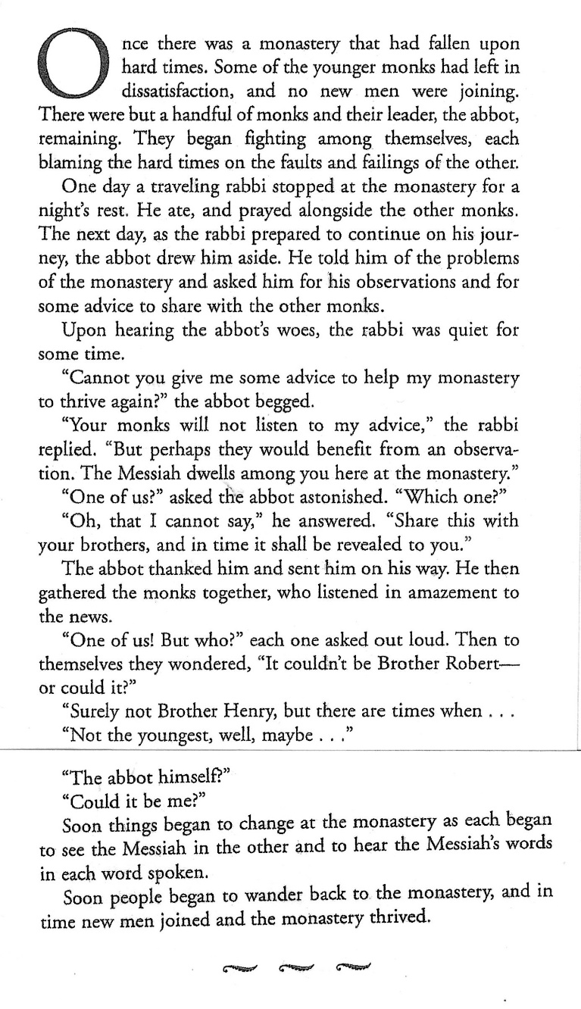
Now that would be a dream church! Where everyone embraces the fact that “The Messiah is Among Us” and acts accordingly by embodying the spirit of the Messiah and reflecting it back to one another! Amen.

© Copyright 2025 by the Rev. Alison Andrea Young

