“Just Visitors” A Lenten Weekday Meditation delivered on Wednesday, March 19, 2025 at the Church of the Brethren in Onekama, Michigan by the Rev. Alison Andrea Young.
We can’t really understand the letter of Paul to the Philippians adequately unless we go back to the Acts of the Apostles Chapter 16 verses 12-40 where the story of the founding of the church in Philippi is told. It was a prayer group predominantly made up of women meeting by the river. Most prominent of the women was the merchant Lydia, a dealer in purple cloth, in whose house the church would eventually have its meetings. After Lydia and her whole household were baptized there by the river because “the Lord opened her heart to respond to Paul’s message“ (v. 14c), Paul and Silas followed Lydia from the prayer meeting back to her house.
During the time that the prayer meetings were by the river, Paul exorcized a spirit of magic from a female slave girl and because this took away the fortune-telling livelihood of her owners, the owners turn Paul and Silas in as traitorous Jews to the authorities who arrest them, beat them, put them in chains and lock them in prison. This is when Paul and Silas began praying and singing to God and an earthquake shook all the prison doors and chains loose. When the jailer realized that no one had sought to escape, he and his household were also baptized and believed. This is the beginning of the church in Philippi.
So, when Paul, now in prison in Rome, writes letters back to the believers in the church he founded there under such miraculous circumstances, the Philippians are sure to listen most carefully. What Paul tells them is that they need to live according to his and his companions’ faithful example. Because the letter is written from prison, they can’t help but remember the time Paul and Silas were imprisoned in their city and how that turned out. Freedom is in Christ is the message, not in the “earthly things” that people seem to be drawn to.
Furthermore, our citizenship is in heaven. We are only visitors here in this human society. The Apostle Paul reminds the Philippians and, of course, us, to “stand firm in the Lord in this way.” (4:1) Perhaps we have only heard the “stand firm” part. It is now time for us to ask the question, “in what way, Paul?” The answer is right there, too, in verse 20. We are to live as “citizens of heaven.” We must, as Mark E. Hopper states in his commentary on Philippians, “examine our own cross-denying ways.” (FOTW, p. 63) And the way to do this, is by imitation. Mr. Hopper emphasizes that this imitation is real, it is “never some kind of slavish reduplication of a pattern, it is rather and incarnation of a living example.” We are not to be “mimes” of a Christ-following life, but flesh and blood embodiments of that way of life. Pierre Teilhard de Chardin, late Jesuit theologian, was majorly influence by the Apostle Paul’s letters. He has famously stated: “We are not human beings having a spiritual experience. We are spiritual beings having a human experience.” As Paul says, “our citizenship is in heaven.”
Commentator Ralph C. Wood explains this concept even further (FOTW, p. 66) He says that when Paul says our citizenship, our commonwealth, is in heaven, he is not making a “sentimental otherworldly promise.” He goes on to explain:
On the contrary, our bodies (and therefore our earthly lives) are so
essential to our souls (and their spiritual lives) that the two cannot be
divided. We are ensouled bodies and embodied souls. We can obey Paul’s
call to “stand firm in the Lord” (4:1) only by following the way of the cross,
only if we are seeking here and now to begin the union of our bodies and
souls . . .”

Indeed, we are “spiritual beings having a human experience!” Paul describes it this way to the Philippians in v. 21, he says that Christ will “transform our lowly bodies so that they will be like his glorious body, . . .”
To this point, here is an Hasidic story that goes like this:
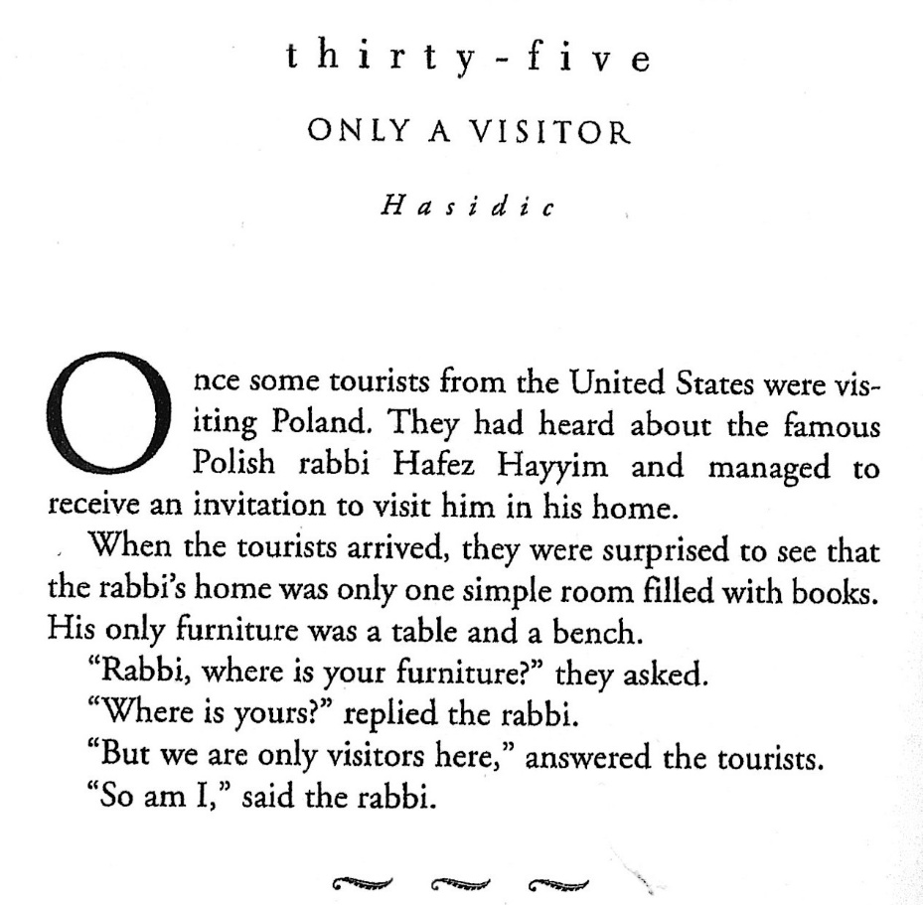

From: Doorways to the Soul Edited by Elisa Davy Pearmain

As spiritual beings we are all visitors here on earth. As visitors we must fill our house with spiritual furniture and always seek to cultivate a spirit of hospitality to all who come our way so that they too may find their way back home to be a “joy and crown” for Jesus. Amen.

