“Holy Hunger” A sermon based on Isaiah 55:1-9, Psalm 63:1-8 and Luke 13:1-9 delivered on the Third Sunday in Lent (Theme: “Hallowed Be Thy Name”) March 23, 2025 at the First Congregational UCC of Onekama, Michigan by the Rev. Alison Andrea Young.

There is an old joke that you may have heard. In Sunday School one day the teacher was trying to teach students about God, and how the Jewish people would not say God’s name when reading scriptures. In fact, she said, God really didn’t have a name, just a title “Yahweh” which means in Hebrew, “I AM.” A young girl held up her hand. She was perplexed. She said, “I thought God had two names—maybe one is just a nickname, but God has two names.” The teacher now looked perplexed. “What do you mean?” she asked. “Well,” the little girl explained, “Don’t we say, Our Father who art in Heaven, Harold be thy name?” And his nickname must be “Andy” because in the hymn we sang last week it says “Andy walked with me, Andy talked with me!”

That word *hallowed* can trip us up every time! Often only associated with “Halloween” or “All Hallow’s Eve,” the night before All-Saints Day, it can have a spurious connotation—even a spooky one. The Greek word, “hagiazdo”, which is translated as hallowed, only appears two times in the New Testament, and both times it is a part of the Lord’s Prayer. The Hebrew word is quodesh (quadash) which means something like “apartness.” That word only appears 20 times in the Old Testament and is, in most cases, a way to describe the Sabbath or priestly things—things set apart as Holy. The Hebrew and Greek words translated as “Holy” are sister words from the same roots as “Hallowed” but they are not exactly the same thing.

The Lord’s Prayer reminds us that God’s very name is “Hallowed”-- set-apart, beyond dissection or translation. While we may call God “the Holy One,” as in our Isaiah passage this morning (55:5c), that is not God’s name—it is God’s attribute. While we may, with the Psalmist we heard from this morning, lift up our hands and call on God’s name, whatever we call out is not God’s name. Perhaps, in this aspect, then, our Jewish brothers and sisters probably have it right when they substitute “Adonai”—my Lord—for the only name God has given God’s self—Yahweh. In Exodus 3:14. God said to Moses “I am that I am,” Tell the children of Israel that “I AM” sent you.” Transliterated, YHWH, vowels unclear, is the only name we are given for God, and this designation of God really isn’t God’s name, either. It is a description of God’s divine eternal being. The one, who is, and was, and is to come. We really aren’t given a name for God until Jesus gifts us with the Lord’s Prayer. Hallowed be God’s name. Set-apart as Holy is God’s undefinable name. This explains a lot about our Lenten journey, doesn’t it? We are seeking something so intangible, so beyond description, so “other” that our longings for it take on a deep hunger and thirst. The prophetic witness and the psalmist that we heard from this morning, provide beautiful descriptions of this “holy hunger.”

Isaiah starts out by saying:

1“Ho, everyone who thirsts,  
    come to the waters;  
 and you that have no money,  
    come, buy and eat!  
 Come, buy wine and milk  
    without money and without price

2 Why do you spend your money for that which is not bread,  
    and your labour for that which does not satisfy?. . . .

6 Seek the Lord while he may be found,  
    call upon him while he is near;”

And Psalm 63 says it even more dramatically:

“1 O God, you are my God, I seek you,  
    my soul thirsts for you;  
 my flesh faints for you,  
    as in a dry and weary land where there is no water. , , ,

 I will lift up my hands and call on your name.  
 5 My soul is satisfied as with a rich feast,  
    and my mouth praises you with joyful lips.. . . “

To what can we compare this hungering and thirsting for God? As with food and drink, is this search for God, the God whose name is “Hallowed,” first and foremost a search for our very survival? For the lifeblood of our souls?

Jesuit priest, Anthony de Mello, tells us a story which answers this question very well, I think: (p. 86 in Doorways to the Soul edited by Elisa Davy Pearmain, © 1989)

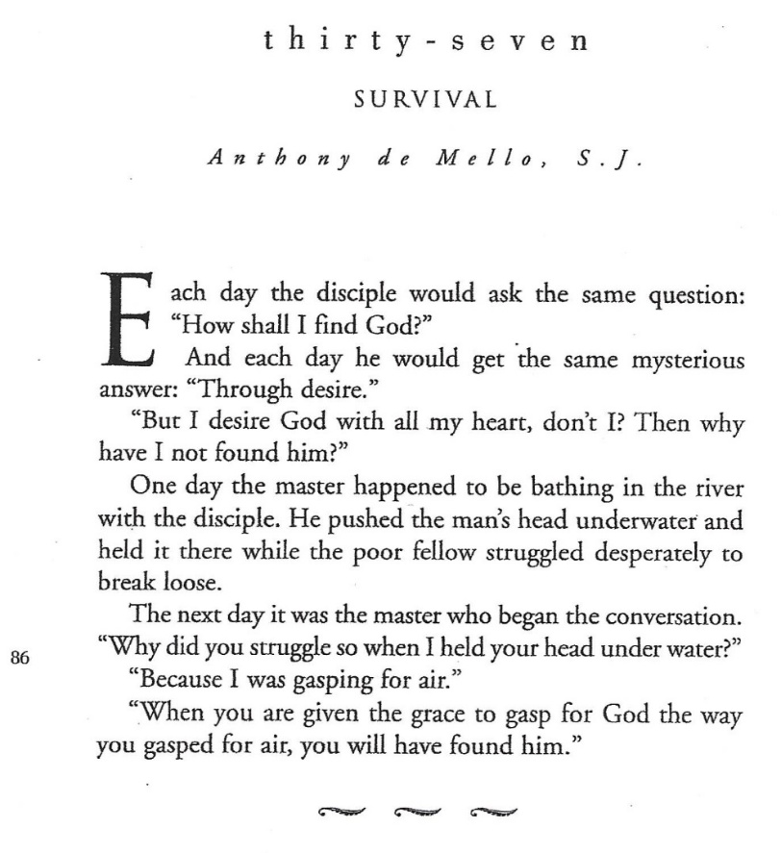

Jim Friedrich, author of the Blog “The Religious Imagineer” asks the question, “Is holiness a Lenten obligation” (2/16/16) As we reflect on the story of the disciple that I just shared, what kind of holiness are we hungry, thirsting and gasping for? Friedrich writes, in answer to his own question, that holiness can only be an attribute of God, “Hallowed be thy name,” but that holiness for us humans “becomes a practice. Not something we are, but something we do.” Kate Bowler and Jessica Richie in their book Good Enough: 40ish Devotionals for a Life of Imperfection, would agree. They say it is hard to look at church history because all the big names had “very dramatic instances of holiness.” They say we need to start small with any spiritual practice we take on. We don’t have to almost drown to keep a Lenten discipline--to seek a modicum of holiness—we just need to be faithful. “Don’t worry about *everything*.” They say. “Focus on the small. Start tiny. And keep it up.” (p. 76)

Jim Friedrich concludes in his blog that “Holiness is meant to be something contagious, something which gets inside us and changes us forever.” This change can make us God’s Holy People. While we will never be “hallowed” we can seek to move ever closer towards goodness. As Gregory of Nyssa, Bishop of Cappadocia in the early church, once said, “holiness isn’t something we achieve, it’s a commitment to growth.” (Life of Moses, 10)

In conclusion, I would like to share the late UCC author and poet, Ann Weems’ poem “God’s Holy People”—

“If you have eyes to see and ears to hear, see and hear God’s Holiness in your life.”

Reach out, take tiny steps, breathe in, breathe out, welcome the Holy Spirit into your being, embrace God’s holiness! Amen.

© Copyright 2025 by the Rev. Alison Andrea Young