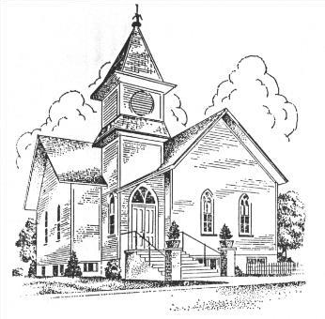 **FIRST CHURCH CONNECTION**

First Congregational UCC of Onekama,

4920 Spring St. PO Box 307 Onekama, MI. 49675

**Church Phone 231-889-4081 e-mail appledumplingchurch@yahoo.com**

**Rev. Alison Young** at 802-829-3211 or ajacobs.4818@gmail.com

**2025**

**Pastoral Ponderings**

There certainly could not be a more “bi-polar” week in history than Holy Week for Christians. Kate Bowler puts it this way:

*Holy Week walks us through rejection, confusion,*

*tears, and death to the heights of resurrection joy.*

*We are Easter people, called to live into hope, but*

*how do we do so when we live in a broken world*

*surrounded by so much to grieve? We must learn*

*to live in the already and not-yet of a world that*

*rejoices in Jesus’ resurrection, but waits for our lives,*

*families, communities, and world to be restored one*

*day too.*

*(From “Bless the Lent We Actually Have: Weekly Group Guide” Week 7)*

What are we to do with the ups and downs of Holy Week when the palms we wave in celebration at the beginning of the week are crushed underfoot by the crowds following the beaten and bloodied Jesus as he carries his own cross through the same streets up to Calvary?

Do we throw up our hands in despair, collapse in a heap weeping, and wonder where this sorry human race will end up? Well, yes, we do all that; but we also raise our voices in prayer and singing. We sit and are nourished by Jesus at the Last Supper, warm our hands over the brasier with Peter, and stand helplessly by while the authorities execute our Savior.

Then on Easter morning we watch the first rays of the sun touch the “new fire” that we have lit to welcome the Resurrection, not only of Jesus, but of our faith in God. It is a week of contrasts, indeed!

As a way to gently walk through and experience this spiritual rollercoaster, I would encourage you to take advantage of the “Seven Stations of the Cross—Seven Last Words” meditative interactive walk that graces our sanctuary on Good Friday (9-5) and Holy Saturday (9-12). This worship event is self-directed and open to all. We hope you will find the experience as meaningful as I do.

May the hope of Easter bless you,

**Pastor Alison**

**Lilies for Easter**

The Worship Ministry team is taking orders for lilies to decorate our sanctuary. The plants will be $15.00 apiece. Make checks payable to the First Congregational UCC of Onekama or pay with cash. Deadline to order: Sunday, April 6, 2025. Make note if the flowers are in **memory** or **honor** of a certain person. Please put order slip and check or cash in the mail slot outside the church office. Thank you!

**In Honor**

**From** **or Memory** **Name(s)**

**Maundy Thursday Service of Tenebrae and Communion**

**in the Sanctuary**

**at 6:00pm,**

**April 17th**

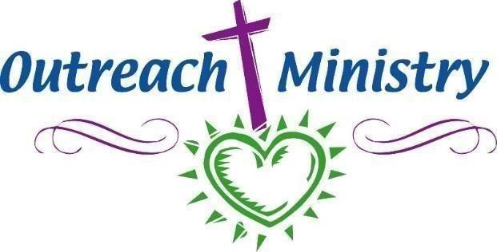

# Manistee Medical Care Facility

Sunday church services at the Manistee Medical Care Facility have been scheduled for Easter **April**

**20th**, and for July 20th and October19th. A small group has arranged to attend and lead the service on **April 20th at 2 PM**. This will be a special Easter Service for the residents and will include our giving the residents Easter baskets as well as conducting the service for them. The visit will be confirmed with staff prior to the service. Those attending have agreed to respect the standard protocols for entering a residential facility.

Call Pastor Alison 802-829-3211 if you have any questions.

**NEW CHURCH WEBSITE**

Drum roll please! “Da Da Teh Da Da” . . .Our new website is up and running!!

Go to: <http://www.onekamaucc.org/>

**And see what all the fuss is about!**

**~Sermons**

**~Newsletters and News Articles**

**~Online Donation Button **

**~UCC Devotional (An especially good one about butterflies is there for**

**March 26th by Quinn Caldwell)**

**~Details about our church leadership and history**

***CHECK IT OUT !!!***

**March Treasurer’s Report 2025**

**Contributions** $- **Food Pantry** $- **Basement lighting** $

**Expenses**

**One Great Hour of Sharing collection will be on May 4, 2025**

This is part of the UCC 5 for 5 programs. This offering channels resources for international programs in health, education and agricultural development, emergency relief, refugee ministries and both international and domestic disaster response. It is administered by the Wider Church Ministries, Global Sharing of Resources. This is an opportunity to contribute to mission work on a national and international level and is completely voluntary

**Spring Brunch**

**For Camp Scholarships - May 18, 2025**

**Immediately Following Worship**

**Bring your donations and your Campfire Stories!**

***COME EXERCISE WITH US ON TUESDAYS AND THURSDAYS***

***3:30-4:30***

*Next session runs from April 1st through May 29th for $80.00 or $5.00 drop-in fee.* Please enter through the red doors as we will be having class in the parlor while our basement is under construction.

**Class Description:**

A strong core, flexibility and balance are your most important assets regardless of your fitness level. This class incorporates core strength training, light weight training upper and lower body workouts,

stretching and balance practice for an overall effective yet not so strenuous workout. (Coed)

*Bring your own weights, and yoga mat or towel for floor exercises.* Chair exercises are an option to floor exercises.

April Goodies

6th

13th

20th  Easter Continental Breakfast in Parlor 9:15am

27th

In the upcoming months, if there is a Sunday that you could help by volunteering, it would be greatly appreciated. Just send me an email with the date.

**Carol Rackow – rackey1992@gmail.com**

.

**LET’S MAKE MAY BASKETS! **

When I was a little girl, I loved May Day. We would make little May baskets out of paper cups with colorful construction paper handles, fill them with wildflowers and hook them to the doorknobs of our neighbor’s houses. It was a thrill to think of them coming home from work to find these little gifts of neighborly affection.

The Day Care center in New Hampshire, where I worked part-time while serving a half-time church, continued my childhood tradition by creating the baskets and taking them around the Village to each house. The kids skipped along the roads laughing with the fun of it as they performed this neighborly activity.

So, on **Thursday, May 1st** would you join me in the parlor to create May Baskets? I will have all the baskets making at the beginning of my office hours that day (9am) and at noontime we can take the baskets around the neighborhood together!

Happy Spring!

Pastor Alison



New Member Opportunity

On Pentecost Sunday, which is June 8th this year, we will be welcoming new members into our congregation. Pentecost was the day in the early days of the church when some 3,000 new members received the Holy Spirit and were baptized into the faith (Acts 2). It is a wonderful time to welcome new members.

If you have been attending the First Congregational UCC of Onekama and wish to formalize your participation here either as a full or associate member, this would be an appropriate time to accomplish that.

Pastor Alison will host two opportunities for a “Conversation on Church Membership” to talk about joining the church and to share information. The two choices for these meetings are: Saturday, May 24th at 2pm or Sunday, June 1st after coffee hour. Please call Pastor Alison at 802-829-3211 if you wish to meet with her at either of these times.

## Monthly 2025 Events & Dates

## 

**Worship** – Every Sunday at 10 a.m. This month Communion will be on the 7th.

**Financial Advisory Committee** – meets on Wednesday April 9th this month at 2:30

**Ministry Council** – 3rd Thurs. each month, this month it is moved to April 24th at 7:00 by zoom.

**Outreach Ministry** – Meeting, Monday, April 7th at 1:00pm.

Game Night is on Friday the 25th this month at 6:00pm

**Worship Ministry** – 2nd Sunday after church.

**Choir Practice -** 3:30 Sunday afternoons.

**Bible Study** – Saturdays April 5,12, and 26 at 10:00am-11:30am

April

St. Joephs Food Pantry

collection item is boxed Mac & Cheese.

Drop yours off anytime

at the church

and we will see it gets there.

**Steps for viewing Facebook Live** **-Streamed Services…**

Be sure to like our page on Facebook “First Congregational Church of Onekama”.

Find the three dots on a post. Click or touch the dots.

Scroll down and turn on notifications for this post.

You will be notified when the page goes live



**April Birthdays**  **Anniversaries**

6th Ron Ludema None this month that we know of.

8th Gail Verplank

9th Dawn Kalis

10th Ellery McIsaac

16th Tom Lind

**Church Staff for 2025**

Pastor – Rev. Alison Andrea Young

Moderator – Bill Sawhill

Vice Moderator - Marcia Rogers

Treasurer – Joy Lind

Clerk – Lynn Jans

Secretary – Joy Lind

Pianists – Carolyn Brooks & Kathy Wilson

Choir Director – Dan Wilson

Custodian – Carol Rackow